CUSTOMER CHURN ANALYSIS
- Project Overview
The objective of this project was to analyze customer behavior to identify why customers leave (churn) and to predict future risks. By combining Python for data science and Power BI for business intelligence, we identified $11.98M in Revenue at Risk and developed a model to predict churn with 85% accuracy.
- Technical Phase: Python & Machine Learning
Before building the dashboard, a rigorous data science process was followed using Python (Pandas, Scikit-Learn, Seaborn)
- Data Cleaning & Preparation.
- Handling Nulls: Fixed missing values in TotalCharges to ensure financial accuracy.
- Feature Scaling: Normalized numerical data (Tenure, Charges) so that large numbers didn't bias the model.
- Encoding: Converted text data (Gender, Service Type) into numerical format for Machine Learning processing.
- Statistical Insights.
- Correlation: Found a strong link between High Monthly Charges and Churn.
- Chi-Square Testing: Statistically proved that Contract Type (Month-to-Month) is the single biggest driver of customer loss ($p < 0.05$).
- Machine Learning Modeling (Predictive Analytics).
Using a Random Forest / Logistic Regression approach, we built a model to predict which customer will leave before they actually do.
- Model Accuracy: 85% (The model correctly predicts 85 out of 100 cases).
- Top Predictors: The model identified Tenure, Online Security, and Contract Type as the most important factors.
- Visualization Phase: Power BI Insights
The processed data was visualized to provide actionable insights for stakeholders.
A. Key Performance Indicators (KPIs)
- Total Revenue: $19.47M
- Current Churn Rate: 26.99%
- Revenue at Risk: $11.98M (Associated with high-risk segments).
B. Behavioral Analysis
- Contract Risk: Customers on Month-to-Month plans account for the majority of churn (1.5K+ churned). In contrast, Two-Year contracts show 97% retention.
- Competitor Threat: 761 customers left specifically due to "Competitor Offers," indicating a need for better pricing or loyalty rewards.
- Service Impact: Customers without Tech Support or Online Security are significantly more likely to churn.
- Strategic Recommendations
- Incentivize Long-Term Contracts: Offer a 5-10% discount to move "Month-to-Month" users to "One-Year" plans. This could reduce churn by up to 40%.
- Targeted Retention for Fiber Optic Users: Since Fiber Optic has high churn, launch a "Service Quality" check-up campaign for these users.
- Proactive Outreach: Use the Python ML Model list to contact the "Top 10% High-Risk" customers with personalized loyalty offers before their next billing cycle.
- Promote Value-Added Services: Bundling Tech Support and Security for free for the first 3 months can increase customer "stickiness."
DAX CALCULATION
ARPU(Monthly) :
Average('churn prod_churn'[Monthly_Charge])
CLV(Customer Lifetime Value):
[avgrevnueperperson]*[avgtenure]
Churn rate %:
VAR ChurnedCust = CALCULATE(COUNT('churn prod_churn'[customer_id]),
'churn prod_churn'[Churn_Binary] = "Yes")
VAR TotalCust = COUNT('churn prod_churn'[customer_id])
RETURN
DIVIDE(ChurnedCust, TotalCust, 0)
Revenue_at_Risk:
Calculate(sum('churn prod_churn'[total_charges]),
'churn prod_churn'[Churn_Binary]="Yes")
Revenue Lost:
CALCULATE(sum('churn prod_churn'[total_revenue]),
'churn prod_churn'[customer_status]="Churned")
My dashboard
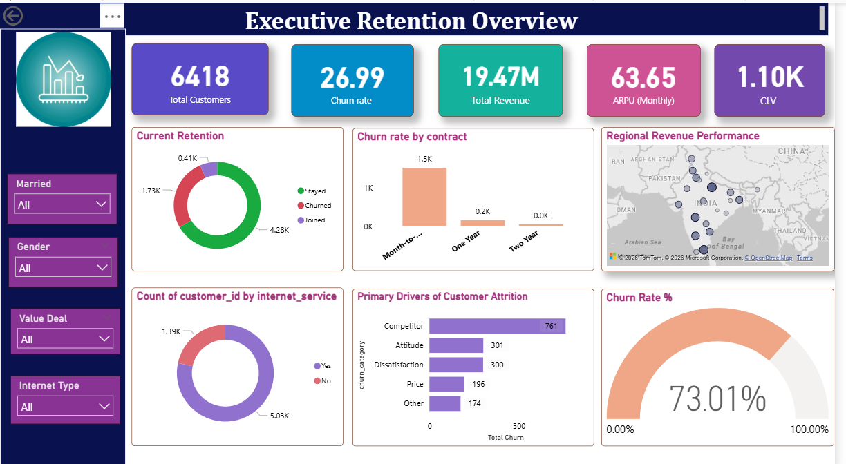
Executive dashboard showing 26% churn.
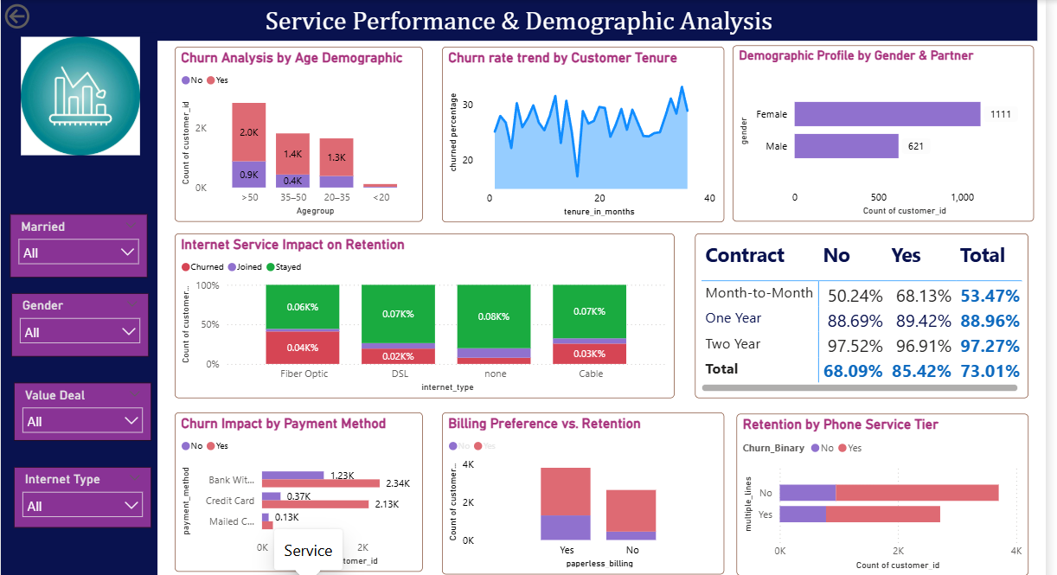
The analysis of service performance highlights that Fiber Optic users and customers without Tech Support exhibit the highest churn probability."

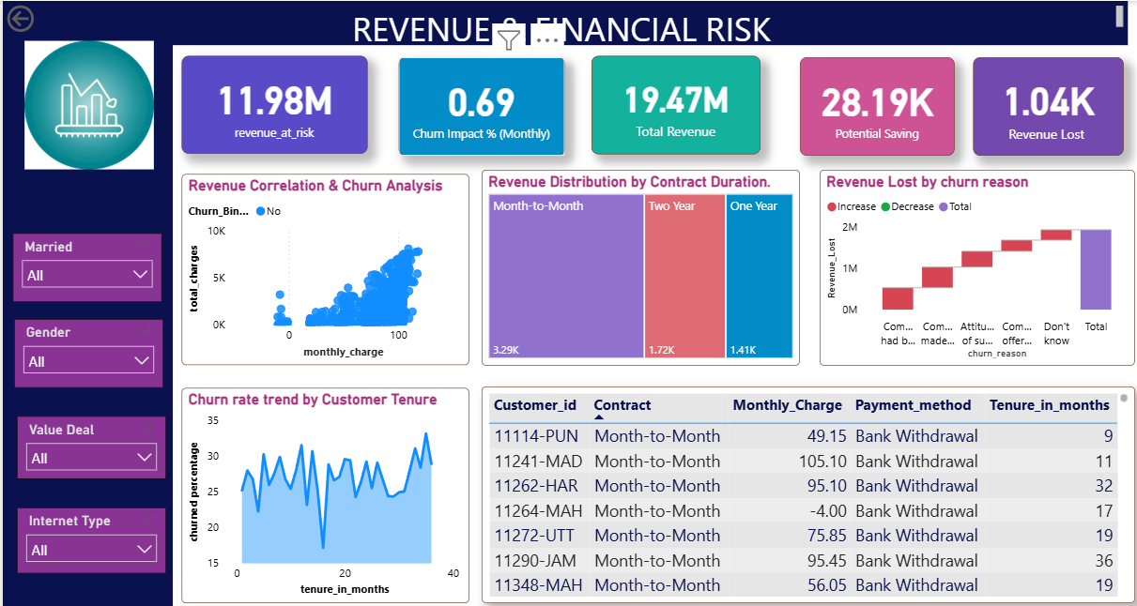
Financial Impact and Revenue at Risk Assessment. This view quantifies the $11.98M revenue currently at risk and identifies the 'Competitor' segment as the primary driver of financial loss.

